**SignWriting**

Many deaf people need to write their own language. There are many ways to represent sign languages in written form: Stokoe notation, Hamburg Notation System (HamNoSys), Gloss Notation, SignWriting, Si5s and ASL-phabet. By comparing these notations based on a set of features such as representation, language dependency, usage, usability for Deaf, way of writing, number of symbols, and non-manual signal (NMS).SignWriting is becoming widespread because it is language independent, which contains large number of basic symbols that can be used to build large number of new symbols, it has a better support for NMS, it is understandable, practical, and it is usable by deaf people in their daily life such as education, communication and reading [1].

SignWriting was developed by Valerie Sutton in the 1974s and it is suitable for all sign languages [2]. Sutton Movement Writing is the International Movement Writing Alphabet (IMWA) which is used to record all human and animal gestures. SuttonMovement Writing has been specified for five fields. They are SignWriting, DanceWriting, MimeWriting, SportsWriting and MovementWriting. SignWriting is for writing the movements of Sign Languages. DanceWriting is used for writing dance choreography. MimeWriting is for writing classic pantomime. SportsWriting is for writing ice skating and gymnastics routines and MovementWriting is used for gesture-based research. SignWriting is the most-used section of Sutton Movement Writing.

SignWriting is a writing system of sign languages using a combination of iconic symbols and the shapes of characters, that are abstract pictures of the hand, body, face, and so on. The International SignWriting Alphabet, the ISWA 2008 and 2010, includes all symbols with 30 groups of symbols used to write the handshapes, movements, facial expressions, and body gestures of any Sign Language in the world as shown in Fig. 1 [3]. SignWriting alphabet is composed of seven categories of base symbols: Hand, Movement, Dynamics and Timing, Head and Face, Body, Detailed Location, and Punctuation. It is the first writing system of representing facial expressions such as mouth, eyes, nose, cheeks, teeth and breathing. The number of symbols is extensive and spelling in SignWriting is not yet standardized for any sign language. The other SignWriting symbols from SignWriting subgroups can be seen in Fig. 2.

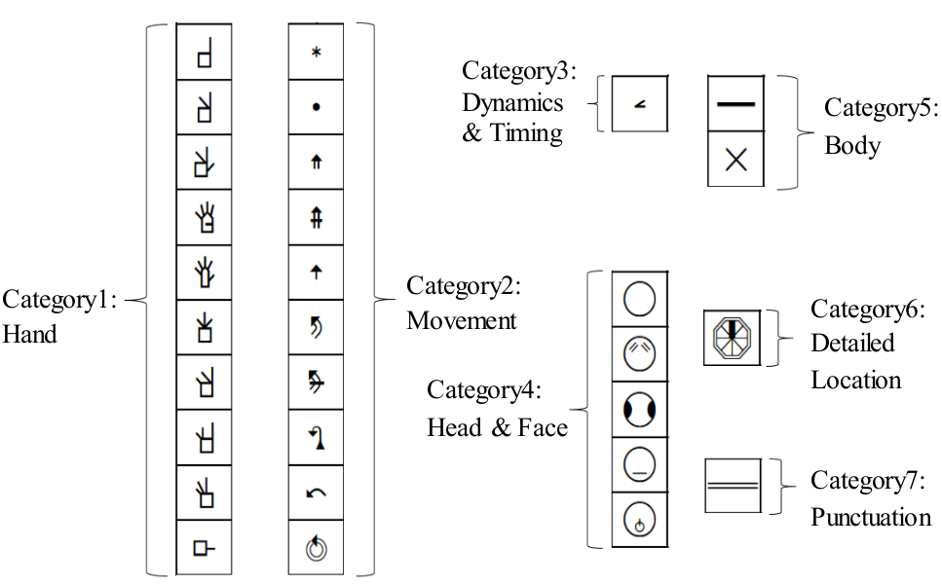

**Fig. 1. Seven Categories and 30 Groups of SignWriting Symbols**

Words in SignWriting may be written from the point of view of the signer and the right hand is dominant. Sutton originally designed the script to be written horizontally (left-to-right), and from the point of view of the observer, but later changed it to vertical (top-to-bottom) and from the point of view of the signer. When another person signs to you, you see his hands. You are an observer. This is called the “observer’s perspective”. And when you sign to someone, you see your own hands. You see the signs from your own perspectives. This way is called the “signer’s perspective” as shown in Fig. 3. The orientation of the palm is indicated by filling the glyph for the hand shape (See Fig. 4). A white glyph indicates that one is facing the palm of the hand, a black glyph indicates that one is facing the back of the hand and half-shading indicates that one is seeing the hand from the side. When the hand is vertical or parallel to the front wall, it can be seen from front view. But when the hand is horizontal or parallel to the floor, it can be seen from top view. There is a small gap between the hand and the fingers in top view concept as shown in Fig.5 , Fig.6 and Fig.7 [4].

|  |  |  |  |  |
| --- | --- | --- | --- | --- |
| **(a) Eyebrows** | **(b) Eyes** | **(c) Head Movements** | | **(d) Teeth** |
| **(e) Blowing/Sucking Air** | **(f) Cheeks** | | **(g) Eye Gaze** | |
| **(h)**  **Tongue** | **(i) Shoulders** | | | |
| **(j) Mouth** | **(k) Punctuation** | | | |

**Fig. 2. Some of SignWriting Symbols**

Signwriting is the first writing system for sign languages to be included in the Unicode Standard. The set of characters is based on SignWriting’s standardized symbol set and defined character encoding model. The Unicode block for Sutton SignWriting is U+1D800—U+1DAAF [5]. The signs of Myanmar sign language can be written using these symbols.

|  |  |
| --- | --- |
|  |  |
| **(a) Observer’s Perspective** | **(b) Signer’s Perspective** |

**Fig. 3. Two Perspectives or Two Viewpoints**

|  |  |  |
| --- | --- | --- |
|  |  |  |
| **(a ) The Palm** | **(b) The Back of Hand** | **(c) The Side of Hand** |

**Fig. 4. Hand Orientation**

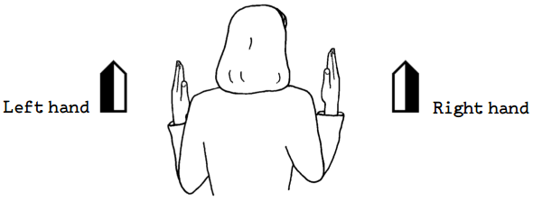

**Fig. 5. Hands**

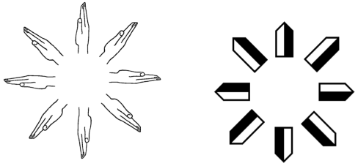

**Fig. 6. Rotating the Hand**

|  |  |
| --- | --- |
|  |  |
| **Front View** | **Top View** |

**Fig. 7. Two Points of View**

**1. Usage of SignWriting Symbols**

**1.1. Contact Symbols**

SignWriting includes symbols that tell what kind of contact the hands make during the sign [6]. Touch (): An asterisk is used to mean touch. The touch symbol is used when the hands touch each other or some part of the body. The touch symbol is put near the place where the two hands touch each other.

Two asterisks () mean that the hands touch twice. Brush (): Brush is a light contact in which the hand slides across another surface and then separates again. Rub (in a circle) (): A rub is when your hand makes circular contact with another part of the body, staying in constant contact without ever separating. The motion of rubbing in a circle is written with a spiral. Rub (in a straight line): This type of contact is written with the same spiral symbol, but it is written with one or more arrows. When the rub symbol is written with an arrow, the arrow determines the direction of the movement. The movement is made with constant contact in the direction(s) of the arrow.

Hold (): Hold means that the hand grabs and holds another part of the body, the hair, or a piece of clothing. Hit/Strike (): Hit/strike means contact that is more forceful than a simple touch. It does not slide across a body part; it simply hits.

In-Between (): In-between means any kind of contact between two other body parts. It is most often used for when the hand passes between fingers, but it can also mean that the nose is between the fingers or the hand is between the upper arm and the body.

**1.2. Finger Movements**

Finger Movements symbols can be used to represent the movement of fingers. There are many forms of finger movement in SignWriting. Middle joint closes (): When the finger bends in the middle, as in a squeeze, this finger movement is written as a black dot. The black dot is written close to the finger as shown in Fig. 8. Two black dots mean two squeezes.

Middle joint opens (): When the fingers are extended, as in a flick, the opening movement is written as a white circle. The circle is written close to the fingers that flick open or close to the place here the movement is done as shown in Fig. 9. Two circles mean two flicks.

Opening and closing fingers (): The fingers move together, opening and closing from the knuckles, as if they were one unit. They are bent and extended together. This movement represented by a string of arrow heads that point up and down (any direction is fine) can be seen Fig. 10. Alternating opening and closing (): The fingers alternate moving up and down, like drumming your fingers on a table. The symbol for this alternating movement is two rows of small arrow heads pointing up and down as shown in Fig. 11.

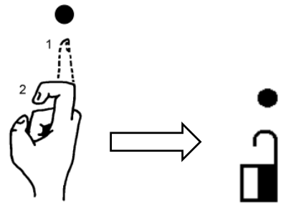**Fig. 8. Example Usage of Black Dot for Finger Movements**

Bending the fingers (): When the fingers bend from the knuckle, this movement is written as the tip of a small arrow head that points down as shown in Fig.12. When there are two arrowheads, the fingers bend twice as shown in Fig.13.

Extending the fingers (): When straight fingers are extended from the knuckles, the movement is written as a small arrow head that points upward as shown in Fig.14. Two arrow heads mean that the fingers are extended twice.

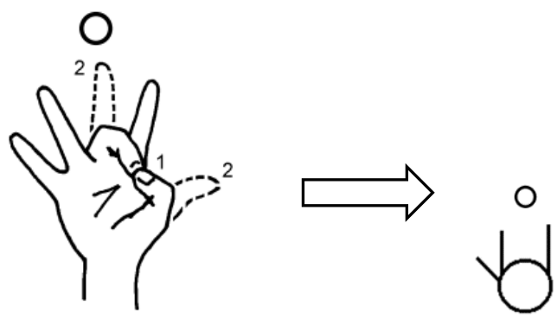**Fig. 9. Example Usage of Joint Open for Finger Movements**

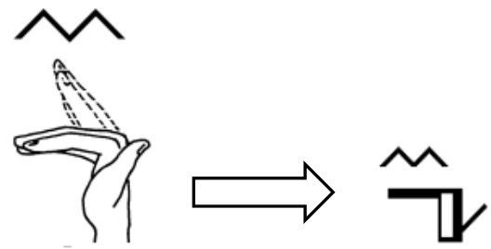**Fig. 10. Example Usage of Opening and Closing Fingers from the Knuckle**

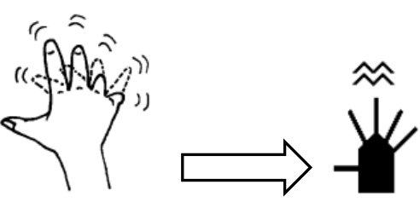**Fig. 11. Example Usage of Alternation Opening and Closing Fingers**

**from the Knuckle Joints**

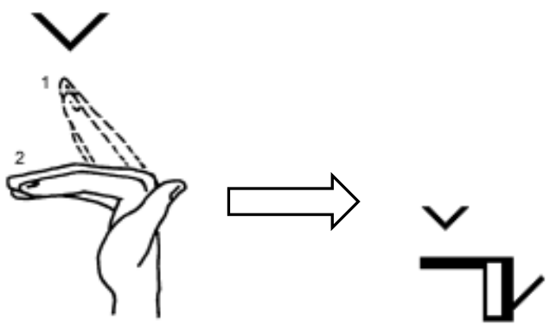**Fig. 12. Example Usage of Bending Fingers from the Knuckle**

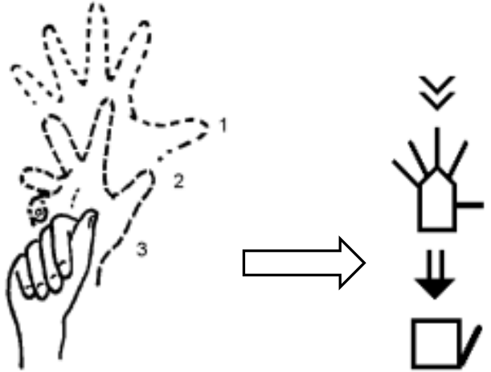**Fig. 13. Example Usage of Closing Hand from the Knuckles, One Finger at a Time**

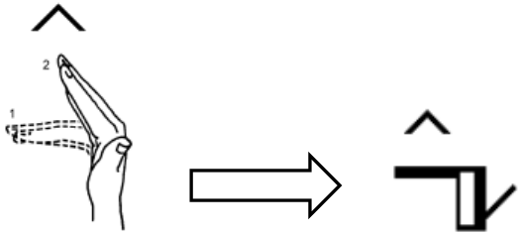**Fig. 14. Example Usage of Extending Fingers from the Knuckle**

**1.3. Movement Arrows**

SignWriting has arrows for various kinds of circular movements. Up-down movements (): They are parallel to an imaginary wall in front of the signer on the vertical plane. They are written with double-stemmed arrows as shown in Fig. 15. Back-and-forth movement (): It is movement that is parallel to the floor. It is written with single-stemmed arrows as shown in Fig. 15. Left-hand movements(): When the arrow head is white, the left-hand moves. Right-hand movements (): When the arrow head is black, the right-hand moves.

Both hands move as one unit (): When the hands touch each other and move together in the same direction, they move as a unit and need only one arrow, with a special arrow head. This is called an open arrow head and it means that both hands do the same thing while touching each other.

Rotation alternating hits ceiling (): These two arrows represent movements that curve over the top of the circle. The first comes back toward the signer in an arc, and the second goes up and over in an arc away from the signer. Single-stemmed arrows with wider sections nearer the signer are used because the basic movement goes more back and forth than up and down. The arrow stem is thicker when the hand is closer to the body and thinner when it is farther away.

|  |  |
| --- | --- |
|  |  |
| **(a) Up-Down Movement** | **(b) Back-and-Forth Movement** |
|  |  |
| **(c) Movements that are parallel to wall, or up and down** | **(d) Movements that are parallel to the floor, or back and forth** |

**Fig. 15. Movements**

Rotating alternating hits floor (): These two arrows represent movements that curve at the bottom part of the circle. The first represents a movement that comes closer as it curves under; the second curves down and under as it moves away from the signer. The basic movement is back and forth. The arrow stem is thicker when the hand is closer to the body and thinner when the hand moves away from the body. Rotating alternating hits chest (): These two arrows represent up-and-down movement that curves toward the body. The basic movement is up and down so the arrow used is double stemmed. The black dot between the arrow stems means that the hand moves closer to the body during its trajectory and then moves away.

Curve Hits Front Wall (): These two arrows represent up-and-down movement that curve toward the horizon. Double-stemmed arrows are used because the basic movement is up and down. The line that crosses the arrows represents the horizon; it means that the hand moves farther away from the body as it moves up or down, then it comes closer again.

**1.4. Dynamics and Timing**

There are SignWriting symbols to represent the dynamics and timing of signing. At the same time (): When a movement is written for both hands, this “tie” symbol unites the movements to indicate that both hands move at the same time. The movement is simultaneous. At the alternative time ():When the circular movement is written for both hands and the hands alternate, this symbol is used to show that the hands alternate as they circle.

Every other time (): When you want to write a movement in which one hand moves and then the other, this symbol is used. It means that one hand completes its action before the other starts to move. This symbol is related to the ties that represent simultaneous movements and alternating movements that we have already learned. Tense (): When writing a sign that is pronounced with the muscles more tense than normal, this symbol is used.

**1.5. Head and Face**

The Face: Sometimes it’s hard to see which configuration is being used when the hand symbol is placed on top of the face symbol as shown in Fig. 16. To write these SignWriting symbols with face, a small semi-circle (scoop) is selected on the bottom of the face that the hand touches. The hand and contact symbols are written near the semicircle.



**Fig. 16. SignWriting Notation for ‘ကျေးဇူးတင်ပါတယ် (Thank You)’ Sign**

The Nose: When the nose is the point of contact for a sign, a short vertical line down the center of the face represents the nose. The contact symbol can be written on the nose line, on the face near it, or off to the side of the face, whichever is clearer. The Eyes: When the focus of a sign is the eyes, or when the point of contact is the eyes or close to them, small semi-circles are written to represent the eyes. The Mouth: If it is important to write exactly what the mouth is doing (smiling, frowning, etc.), the expression inside the circle that represents the face can be written as shown in Fig. 17.

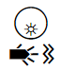

**Fig. 17. SignWriting Notation for ‘ရေ (Water)’ Sign**

**2. Development of Myanmar SignWriting Dictionaries**

Myanmar sign language (MSL) do not have a traditional or formal written form but the signs of Myanmar sign language can also be written using these SignWriting symbols. In Myanmar deaf society, there are very few MSL users who know about SignWriting writing system and this will be the first SignWriting text input interface for Myanmar sign language. Because there is no predefined Myanmar SignWriting for MSL in Myanmar Deaf society yet, Myanmar SignWriting (MSW) dictionary is needed to build. Therefore, Myanmar sign languages and SignWriting have also been studied by ourselves. The spoken style sentences and written style sentences are manually selected from the pamphlets, emergency alerts, emergency books, daily basic conversation book, other general domain books and history book, Mary Chapman School for the Deaf, Yangon.

Firstly, sign language trainers are discussed for each sentence whether the usage of each sentence is possible or not for hard-of-hearing people and whether it is usable for them. Sometimes, they discuss with other deaf people by themselves how to translate and show with sign languages. It is needed for each sign and write down with Myanmar text. And then, sign language video data are collected to record how they sign as shown in Fig. 18.

|  |  |  |  |
| --- | --- | --- | --- |
|  | |  | |
|  |  |  |  |
|  | |  | |

**Fig. 18. Recorded Photos During Data Collection**

Video data are collected with professional Myanmar deaf signers from School for the Deaf (Mandalay), Mary Chapman School for Deaf Children (Yangon), School for the Deaf, Tarmwe (Yangon) and Myanmar Deaf Society (MDS). There are 13 native signers and sign language trainers involved – four are male and nine are female singers respectively. The participants’ ages ranged from 20 to 48 years. After video data collection, the defining of SignWriting symbols for each sign of MSL had been made. In details, the recorded video was watched several times for defining both manual and non-manual signs. After that, sign symbols are placed on the canvas of SignMaker [7] to form the shape and movement of signs. The sign of ‘Exam’ can be defined with SignWriting symbol in SignMaker as shown in Fig. 19.

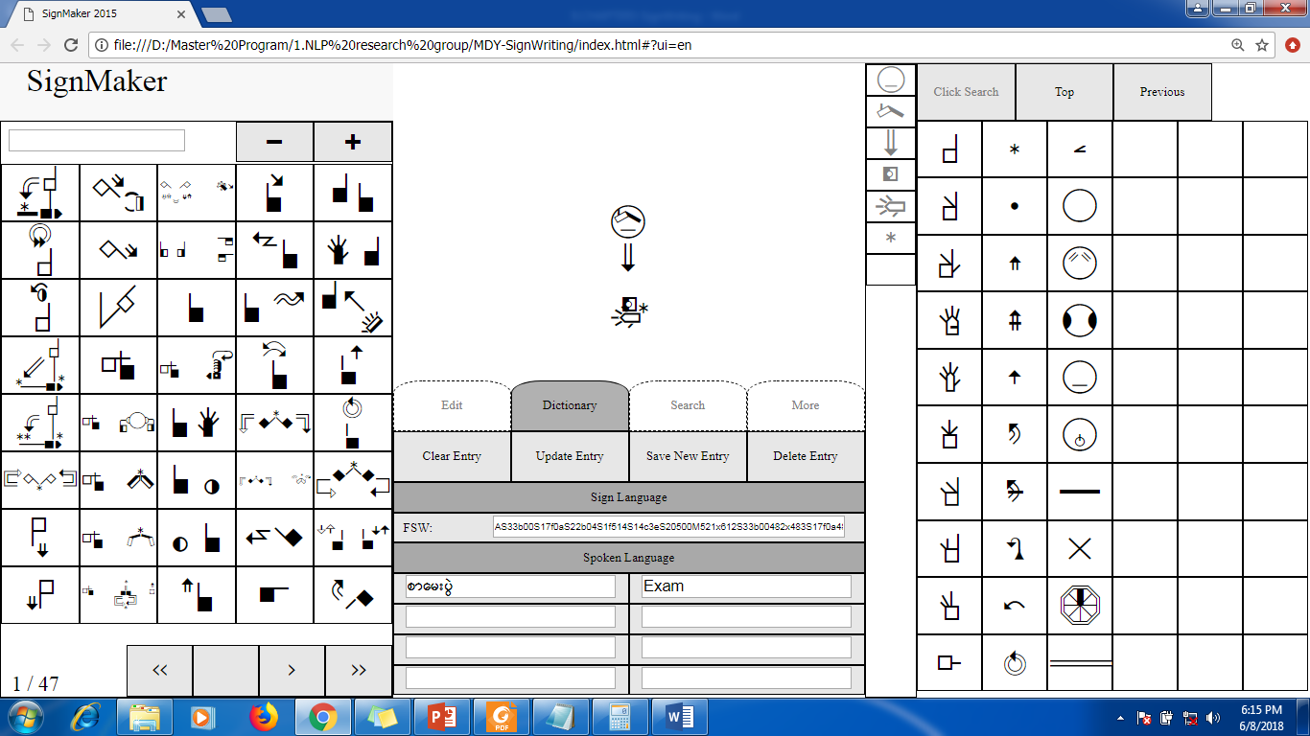

**Fig. 19. Example of MSL Word ‘Exam’ Written in SignWriting Symbol**

MSW words are defined on computers and worked on the web or locally without an internet connection. SignMaker2015 is a standalone web application that features SignWriting TrueType Fonts and an integrated SignWriting dictionary. TrueType font is developed for writing any sign language with International SignWriting Alphabet 2010 (ISWA2010). SignWriting symbols are needed to arrange in a unique sequence. The output file is javascript file and can be reused it by importing in next time. Examples of MSL words and Myanmar sentence written in Myanmar SignWriting words can be seen in Table 1 and Fig. 20.

**Table 1. Example of Writing Myanmar Sentences with SignWriting Symbols**

|  |  |  |  |  |
| --- | --- | --- | --- | --- |
| Myanmar Sentence: | ငလ်င္လႈပ္ေနရင္ ဓာတ္ေလွကား အသံုးမျပဳနဲ႔။ | | | |
| Myanmar Sign Language: | ငလ်င္လႈပ္ | ေနရင္ | ဓာတ္ေလွကား | မသံုးရ။ |
| Myanmar SignWriting: |  |  |  |  |

|  |  |  |
| --- | --- | --- |
|  |  |  |
| **Sign of ‘King’ in MSL** |  | **MSL of ‘King’ with SignWriting Symbol** |

**(a) Sign of ‘King’**

|  |  |  |
| --- | --- | --- |
|  |  |  |
| **Sign of ‘Heir’ in MSL** |  | **MSL of ‘Heir’ with SignWriting Symbol** |

**(b) Sign of ‘Heir’**

|  |  |  |
| --- | --- | --- |
|  |  |  |
| **Sign of ‘Clerk’ in MSL** |  | **MSL of ‘Clerk’ with SignWriting Symbol** |

**(c) Sign of ‘Clerk’**

**Fig. 20. Example of MSL Words Written in SignWriting**

**3. Implementation of Myanmar SignWriting Text Input Interface**

The implementation of this input editor is set up on Ubuntu desktop computers running Ubuntu 16.04 LTS Linux OS. The graphical user interface is implemented with Python programming language. Myanmar SignWriting (MSW) text input interface for Myanmar sign language can be seen as shown in Fig. 21. when the program starts.

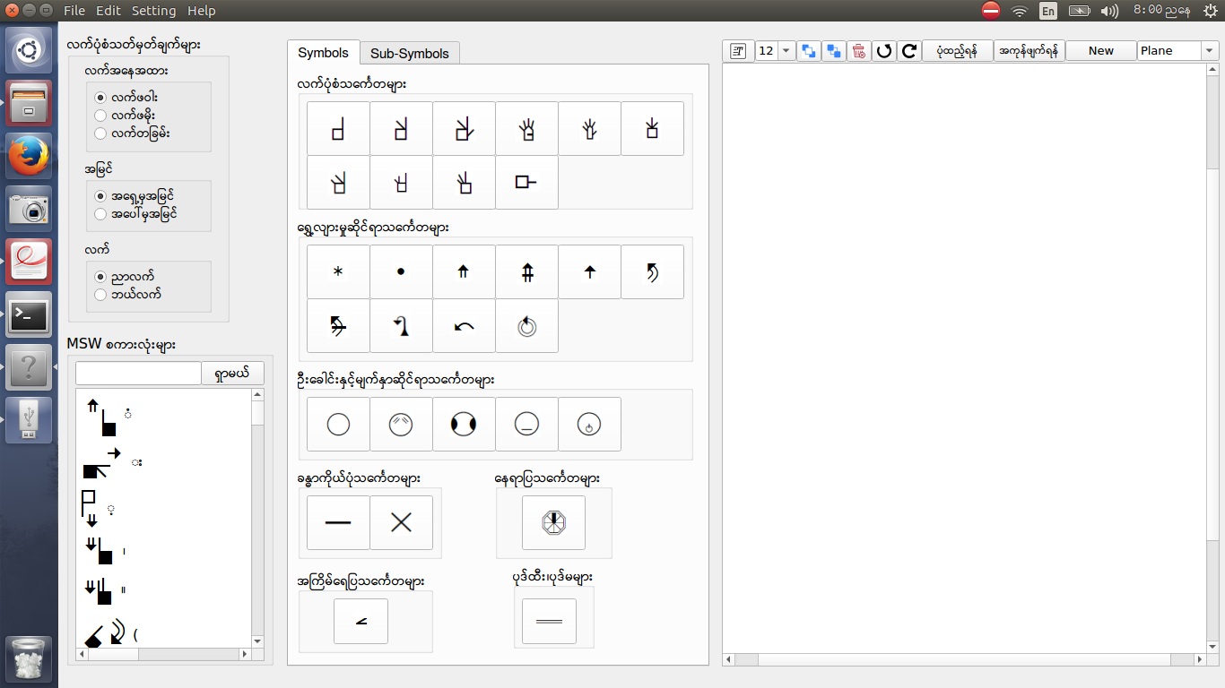

**Fig. 21. MSW Text Input Interface for Myanmar Sign Language**

From this first page, one desired symbol can be chosen from seven categories of SignWriting symbols such as လက်ပုံစံသင်္ကေတများ (Hand), ရွေ့လျားမှုဆိုင်ရာသင်္ကေတများ (Movement), ဦးခေါင်းနှင့်မျက်နှာဆိုင်ရာသင်္ကေတများ (Head and Face), ခန္ဓာကိုယ်ပုံသင်္ကေတများ (Body), နေရာပြသင်္ကေတများ (Detailed location), အကြိမ်ရေပြသင်္ကေတများ (Dynamics and Timing) and ပုဒ်ထီး၊ ပုဒ်မများ (Punctuation). Then, in the Sub-Symbol tag, there are other symbols of symbol that chose. For example, if you choose index-finger of hand symbol from Symbols tag, the other symbols of index-finger can be seen in Sub-Symbols tag as shown in Fig. 22. You can also see detailed information of SignWriting symbols by moving over the button of the SignWriting symbol as shown in Fig. 23.

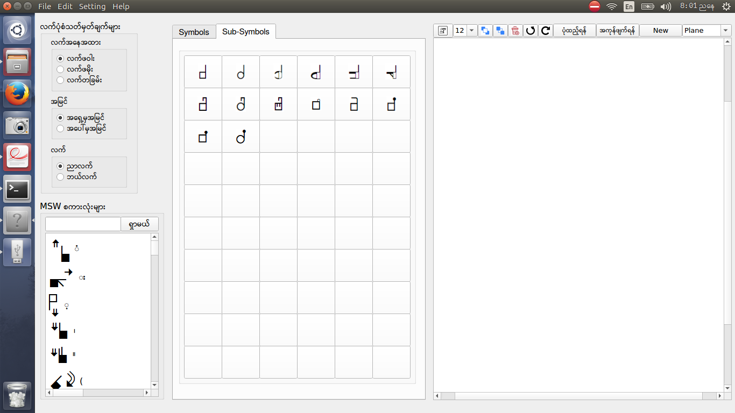

**Fig. 22. Choosing of Index-finger from Hand Symbol Group**

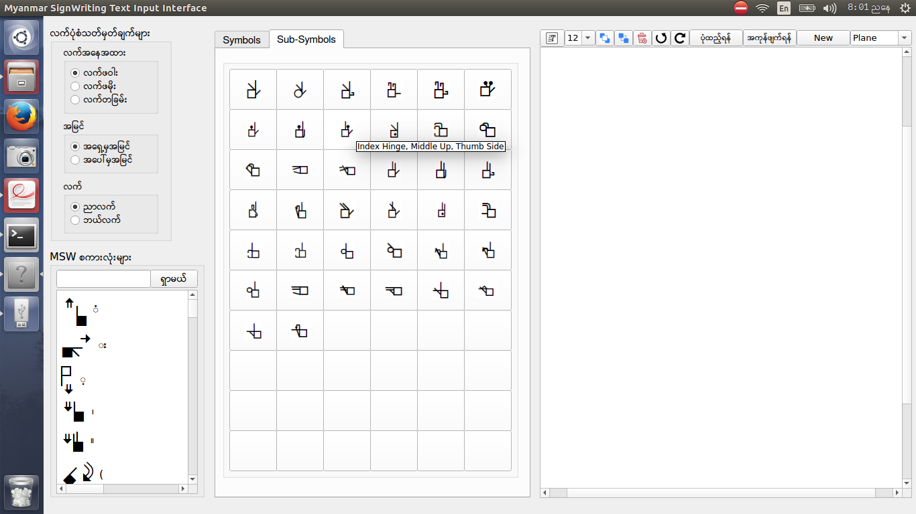

**Fig. 23. SignWriting Symbol with Detailed Information**

If the symbol is chosen from Hand symbol group, the position of Hand should be considered before using these symbols. In the position of Hand, there are three main parts: hand orientation, view point and hand. The default of hand orientation is palm of hand. A white glyph indicates that one is facing the palm of the hand, a black glyph indicates that one is facing the back of the hand and half-shading indicates that one is seeing the hand from the side. If the symbol for the palm of hand is wanted to use, “လက်ဖဝါး” option should be chosen, or when the symbol for the side of hand is used, “လက်တခြမ်း” option should be selected, or when the symbol for the back of hand is used, “လက်ဖမိုး” option should be used as shown in Fig. 24.

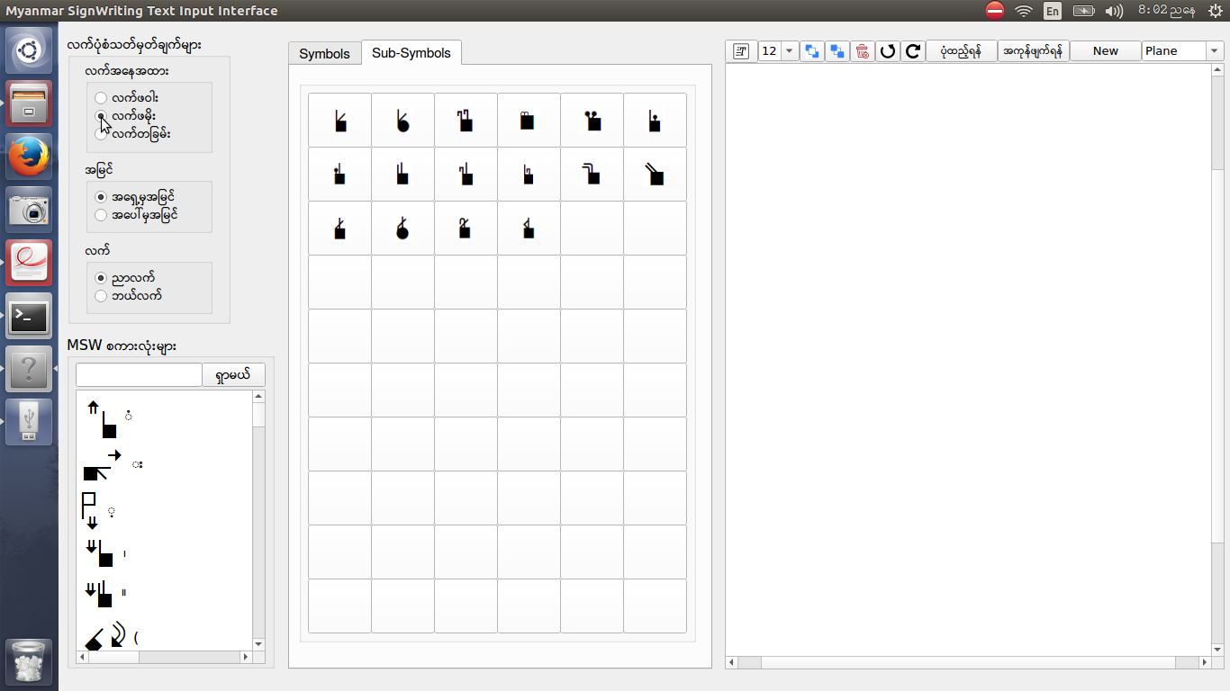

**Fig. 24. Choosing of “လက်ဖမိုး” Option for Index-finger Symbol**

For the hand that is vertical or parallel to the front wall called Front view, “အရှေ့မှအမြင်” option can be chosen. And “အပေါ်မှအမြင်” option can also be chosen as shown in Fig. 25 for the hand that is horizontal or parallel to the floor, also known as Top view. In view point, the default view point is Front view.

In SignWriting writing system, words may be written from the point of view of the signer and the right hand is dominant. So, in this user interface, the default hand is right hand. But sometimes, the left hand is needed to use when both hands are needed to express. The symbol can be changed to left hand by choosing “ဘယ်လက်” option as shown in Fig. 26.

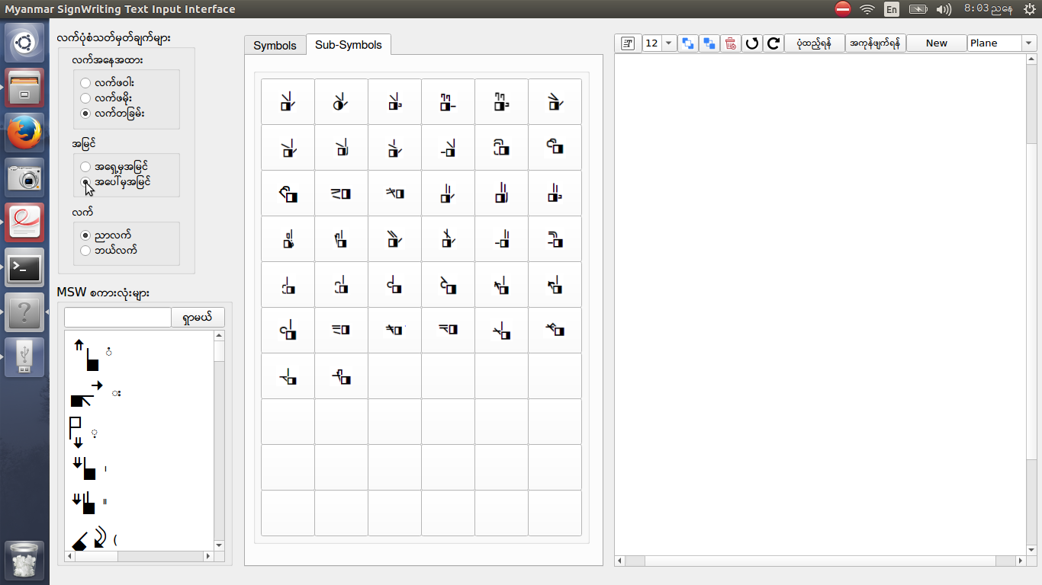

**Fig. 25. Choosing of “အပေါ်မှအမြင်” Option for Index-finger Symbol**

Some of Myanmar SignWriting (MSW) words are predefined for Myanmar sign languages and supported in this input interface. Some of words can be searched with Myanmar words and MSW words that matched with typed words can be seen. And these words can also be used by clicking words. Example of searching MSW word of “အမေ” can be seen in Fig. 27. Example of writing a sentence “မနက်ဖြန်အားလား။” with SignWriting using the proposed SignWriting text input editor can be seen in Fig. 28.

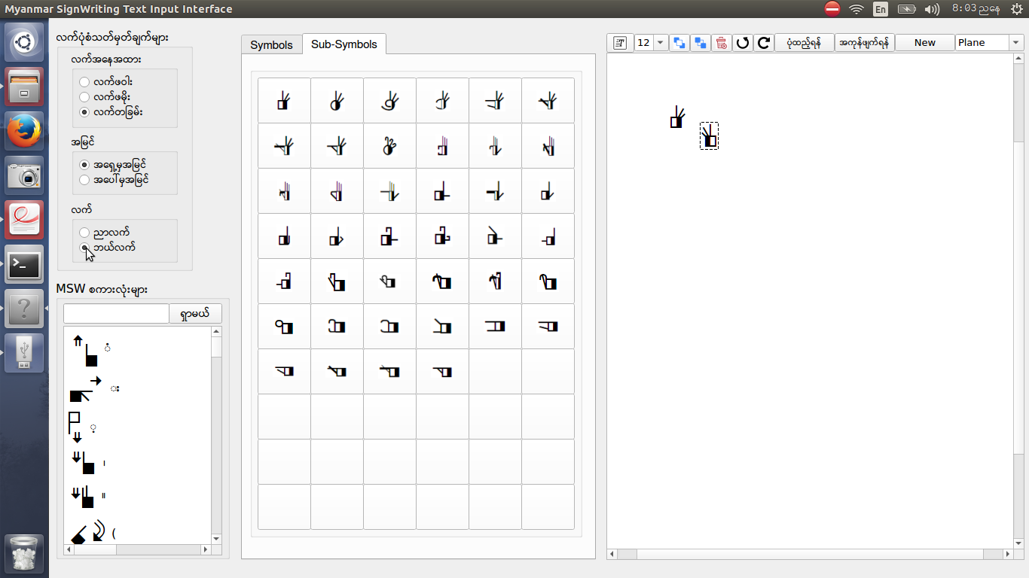

**Fig. 26. Choosing of “ဘယ်လက်” Option for Index-finger Symbol**

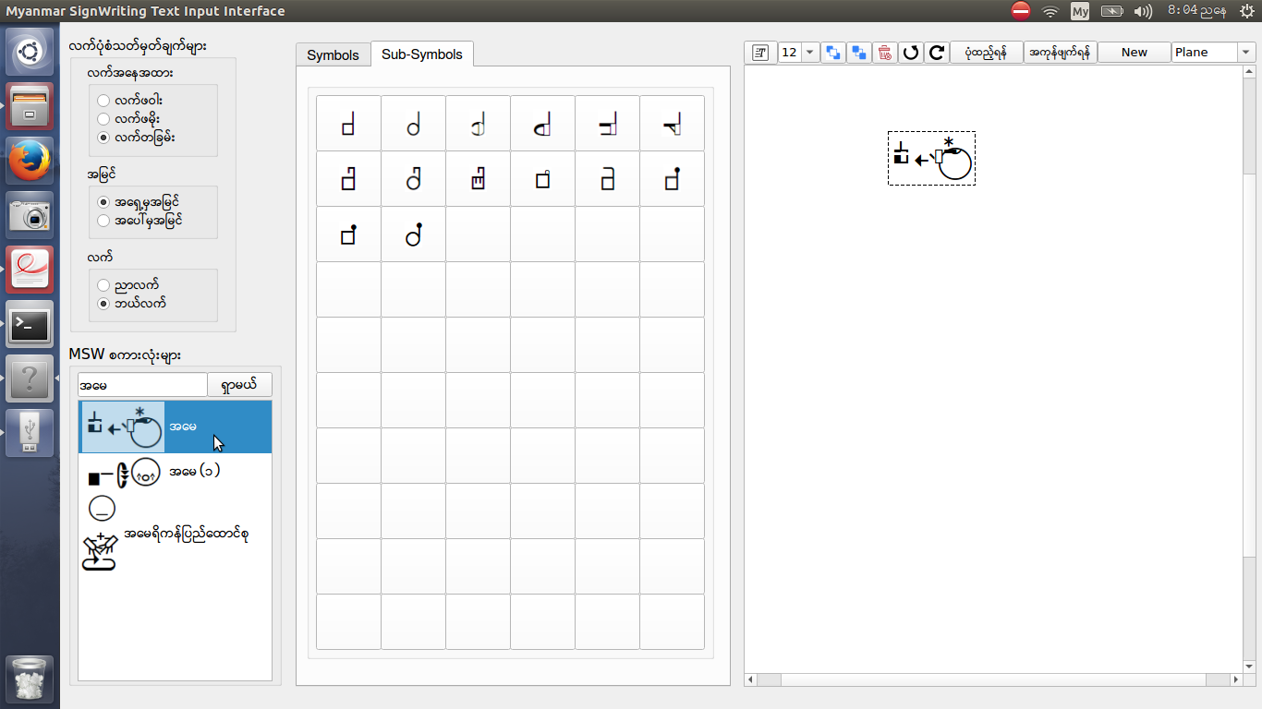

**Fig. 27. Searching MSW Words of “အမေ” Sign**

In this user interface system, Myanmar written text or English written text is also provided to represent MSW words by pressing “Text” button as shown in Fig. 28. In teaching system of deaf people, pictures can be used to demonstrate their sign language. In this user interface, the pictures can also be added in typing Myanmar SignWriting words as shown in Fig. 29.

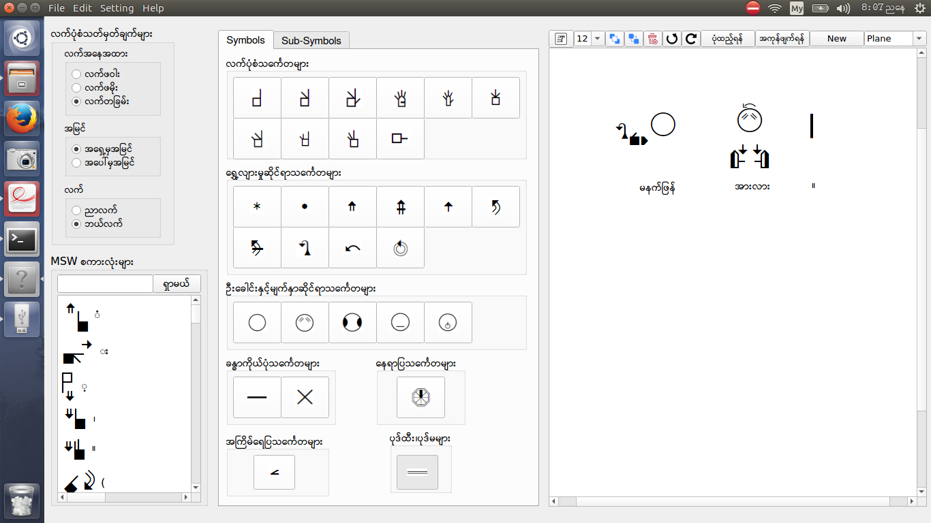

**Fig. 28. Example of Writing a Sentence “မနက်ဖြန်အားလား။” with MSW Word**

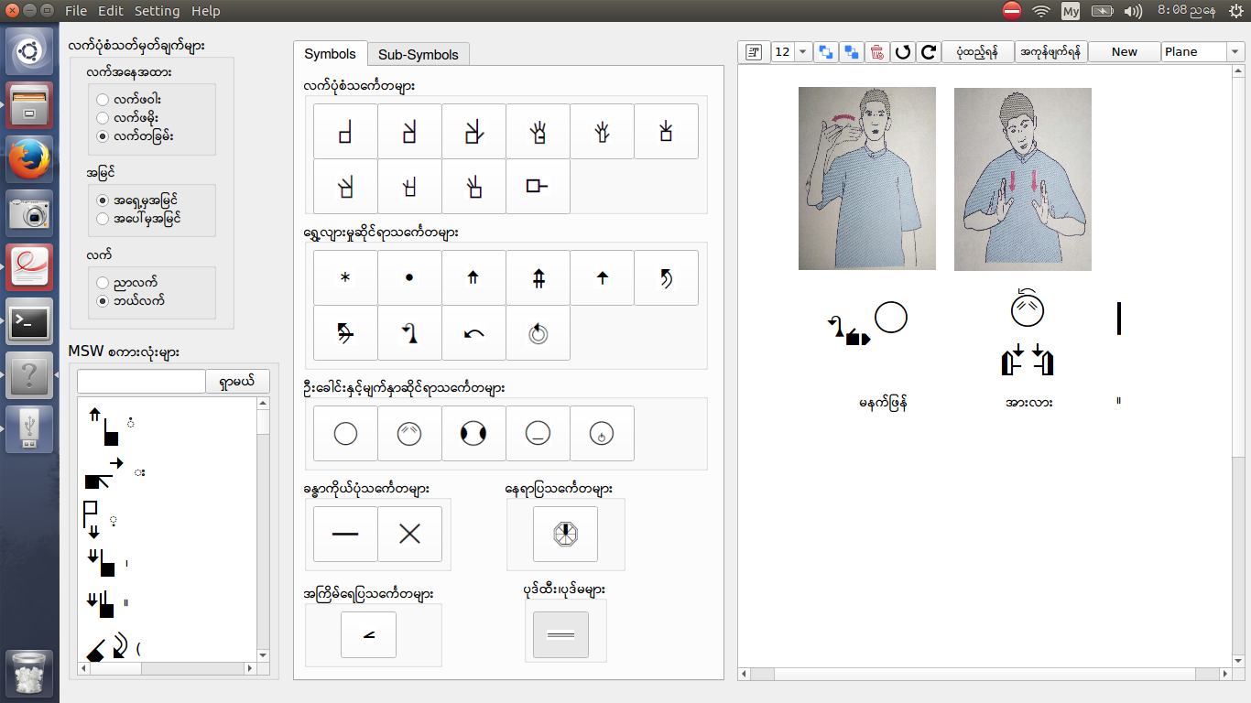

**Fig. 29. Demonstrating Myanmar SignWriting Words with Pictures**

This system also supports many options such as rotation for each symbol by ‘Clockwise’ button or ‘Counter-clockwise’ button, brings the symbol to front by ‘bring to front’ button or ‘Ctrl + F’ shortcut key, sends the symbol to back by ‘send to back’ button or ‘Ctrl + B’, deletes selected symbols by ‘Delete’ button or ‘Delete’ shortcut as shown in Fig. 30 and deletes all symbols that you wrote by ‘Clear All’ button or ‘Shift + Delete’ shortcut. The symbols that you wrote can also be saved, saved as and opened again as a picture format. You can also change the language of user interface and the background design of the writing area as shown in Fig. 31.

**4. Limitations**

SignWriting font is not compatible with the GUI, so each symbol has to be used as an image. Therefore, when you save, you can save as a fixed image. Once saved, you can add more symbols, but you cannot edit the saved one.

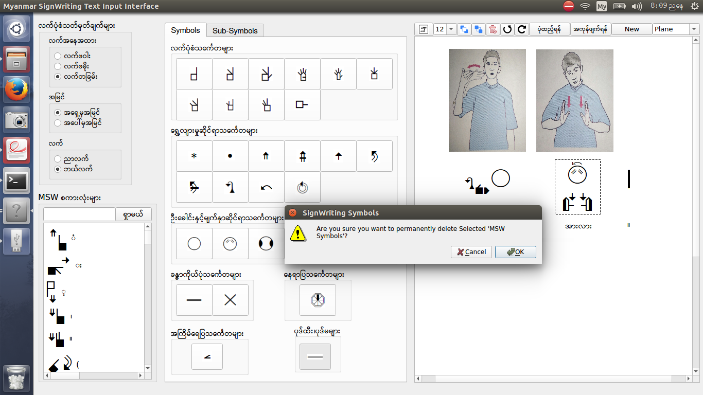

**Fig. 30. Deleting Selected MSW Word**

|  |  |  |
| --- | --- | --- |
| (a) With Boundary Line for Horizontal Typing System | (b) With Boundary Line for Vertical Typing System | (c) Without Boundary Line |

**Fig. 31. Background Design for Different SignWriting Typing System**